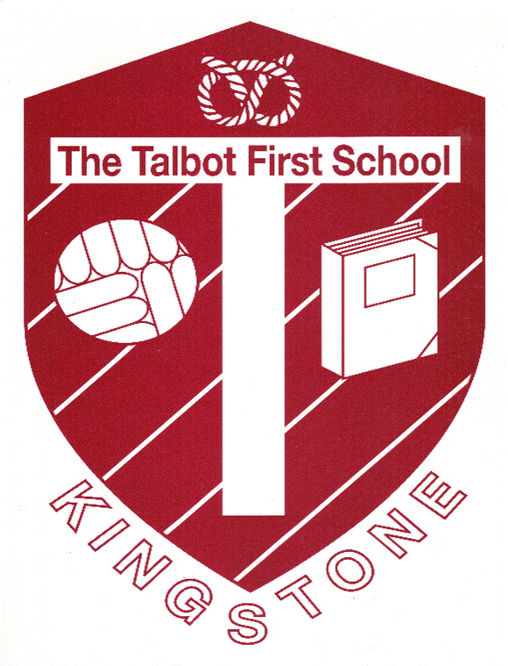

The Woodlands Federation
Talbot First School
Church Lane,
Kingstone
Uttoxeter ST14 8QJ
Email:office@talbot.staffs.sch.uk
Thursday 21st May 2020
Dear Parents,
I hope you are all well and keeping safe and healthy. I am writing to set out the arrangements for the phased return to school from the beginning of June. Since the Government’s announcement on May 23rd, I have been working tirelessly with the staff to read all of the guidance and understand its implications for our setting. Thank you for bearing with us whilst we put together a workable plan that continues to safely support the Keyworker Children whilst being able to open for other year groups. We have conducted the necessary Risk Assessments and taken County Council guidance in all areas of Health and Safety in order to set out the plan for returning to school.
We have named the groups by the room that they will be based in. Class teachers will let you know on Dojo which group your child is in as it may be different to their normal room. We have mixed the year groups in order to have siblings in the same group to limit the mix of households. From 1st June school will be open for the Maple Group (Keyworkers) and from Wednesday 3rd June for the Willow Group ( EYFS/ Year1).
Drop Off:
Could Parents please stay outside the main gate and observe 2m social distancing. It has been recommended that 1 adult only drops the child off where possible. Your child will be met by a member of the team – this will be Mrs Holden, Mrs Grocott, Mrs Fowler or Mrs Chatfield. The children are familiar with all of these adults. They will meet your child at the gate one by one and they will be given some hand gel to clean their hands before entering. We ask that children don’t bring anything in from home except a coat if it is needed which they will be able to put on the back of their chair. Another Team member will then take your child to the classroom door. Can we please request that parents respect social distancing at drop off and pick up times.
Could Children in the Willow Group drop off at 9.00am and collect at 1.45pm
If you have any enquiries as a parent could you:
- ring the school office: 01889 500273
- email: office@talbot.staffs.sch.uk
- or let your child’s teacher know on Dojo

Refreshments throughout the day:
All food and drink will be catered for onsite so please do not send your child with a lunchbox. Snacks and drinks will be provided by staff at break time and lunch will be prepared in the St Peters kitchen, served in the school hall and eaten in the classroom. Staff will fetch the lunches for the children so they do not need to move around the school.
The staff have strict guidance on the type and amount of resources they are able to use throughout the day and will have prepared personal resources for your child that will be regularly wiped down and steam cleaned or disinfected at the end of the day. Any shared resources such as outdoor equipment will be thoroughly cleaned between groups. They have been planning hard and are making the most creative, fun and exciting environment that they are able to. It will feel different but they will be nurturing and supportive and make everything feel as normal and free as possible. Staff have been following training guidance for Wellbeing and will be mindful that your child may feel anxious or unsettled. They will be keeping a close eye to make sure everyone is having a happy time and have a variety of resources to use to support this. If you are concerned about anything in particular give Mrs Holden a Dojo message or email and she will be happy to chat anything through.
Outdoor Play:
We are very lucky to have some great outdoor space and children will be able to access this often. Staff will ensure a rota and clean down to make it safe for all groups to be outdoors.
Collection:
Please wait outside the school gate keeping 2m social distancing. The children will come out to the gate with the staff members and we will call you forward to collect them. They will be able to antibac their hands as they leave. Could we request that parents are prompt to collect and leave promptly afterwards to help minimise the risk of cross infection.
First Aid:
As always we will do our very best to minimise accidents. Government Guidance requires that staff wear full PPE to deal with any First Aid or toileting accidents which includes face mask, gloves, visor and apron. We will show the children what this looks like and put them at ease as much as possible. Government guidance is also that children are encouraged to self-manage any minor injuries as much as possible. Again we will encourage this but will not let your child become distressed and ensure that they have the care that they require. Feeling safe and cared for is a very important part of our job and we will be doing everything we can to help the children.
Toileting:
Staff will clean the toilet and sink after each use. Any accidents will require PPE as above but staff will be reassuring the children and making them feel looked after in the best way they can. We are mindful that small children cannot self-care always in this area. Please be assured that we will be looking after your child and stepping in to help wherever it is needed.
Sunny Weather:
Could you send your child to school with a named hat. We will ensure they get plenty to drink and lots of shade. On sunny days we ask if you could you put sun cream on your child before school. We will have some high SPF lotion in school of which your child can have a squirt to top up if required at lunchtime and outdoor times. Please contact school if you do not want them to have any extra cream on. Children will need to rub it in themselves as normally happens in school, but again we will be encouraging them and supporting along the way.
Signs of Illness:
If your child shows any signs of COVID the DfE Guidance states that we will contact you ASAP and will isolate them in a quiet safe area of the school with a member of staff – we will make them feel comfortable will need them to be picked up ASAP. The child and family will need to be tested and may need to self-isolate for 14 days as will the group of children and staff that have been in contact. Should this situation arise we will give you the required details from the Government.
Classrooms and Learning Spaces:
We have been asked to remove all soft furnishings and rugs as well as reading books and limit the amount of paper on displays. A reduced number of workbooks, resources and toys will be used. All these things will need to be thoroughly cleaned throughout the day and have a clean down as well as the room at the end of the day. In addition staff and cleaning staff will be disinfecting touch points such as door handles light switches etc each day. Once a week the school will have a deep clean ready for the next week. However, staff are working hard to make the learning spaces as exciting and welcoming as possible.
We will also be planning lots of outdoor learning especially as we have great weather.
Staff will be setting similar activities for the children at home as for those in school so you will all be able to do the same fun learning ready for September.
Staff members will stay with the children throughout the day for breaks and lunches so there is no crossover of groups as per DfE guidance.
Staff have found it very strange to have to plan like this as it goes against their caring, nurturing closeness that builds the children’s confidence and underpins our ethos at Talbot School. However they are seeing it as a challenge to come up with new ways to deliver the learning and care of the children so they grow and thrive in the same way.
Staff will also provide follow up activities for Thursday and Friday when your child will not be in school.
Key Worker Club:
Children in the Keyworker Club will be in the Maple Group. They may be dropped off form 8.45am and collected at 3.30pm in the same way as the drop off and collection for other groups. Mrs Chatfield will be working with this group throughout the week.
Phased Return of other Year Groups:
We have had no specific guidance of return of other year groups at this stage but I will be liaising with other Head’s in the area and will send out information about this ASAP.
Year 4 Transition:
Oldfield’s Hall Middle School have sent out a schedule for transition. This has been planned virtually and I will be sending details out to you in a subsequent letter.
Return Dates:
Key worker children may start back at Talbot on Monday 1st June.
School will be ready to open on Wednesday 3rd June 2020 for EYFS and Year 1. This will be a day for your child to see how the school looks and get used to the new rules and changes.
From Monday 8th June the school will be open to EYFS and Year 1 from Mon – Wed each week.
This is subject to confirmation from the Government that it is safe to open. We will keep you informed of any changes.
We are hoping to then get in children from other year groups as soon as we are able and will let you know when we have had any guidance needed and finalised a plan for this.
All of the new regulations have felt very strange for us to have to put in place. The staff are passionate about caring for your child and getting them to reach their full potential. They are working tirelessly to make the changes as fun and easy as possible. We have missed you so much over the last few weeks. We look forward to you all returning safely and promptly so that Talbot can feel whole again.
If I have forgotten anything that you would like to ask about or if you have any further questions please contact the school office or one of the teachers on Dojo.
Thank you for your support and patience in these unprecedented times.
Very Best Wishes from myself and all of the staff,
Helen Wright

